# Business Analyst Capstone Project – E-Fixed Deposits:

**Stakeholders:**

1. ABC Bank
2. Customers of ABC Bank
3. Management and staff of ABC Bank
4. Potential customers of the ABC Bank
5. Regulatory Bodies
6. IT Team

# As-Is Diagram:

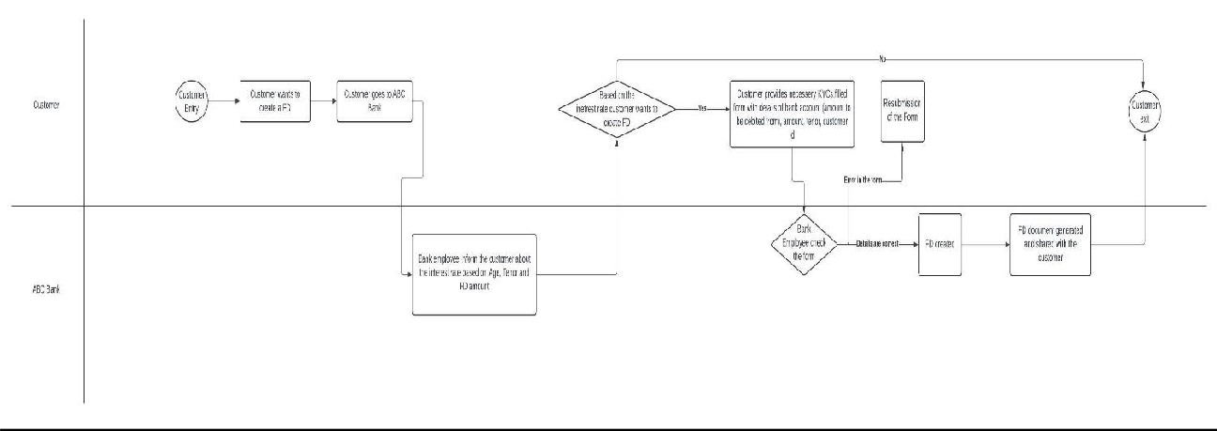

**Future Process Map:**

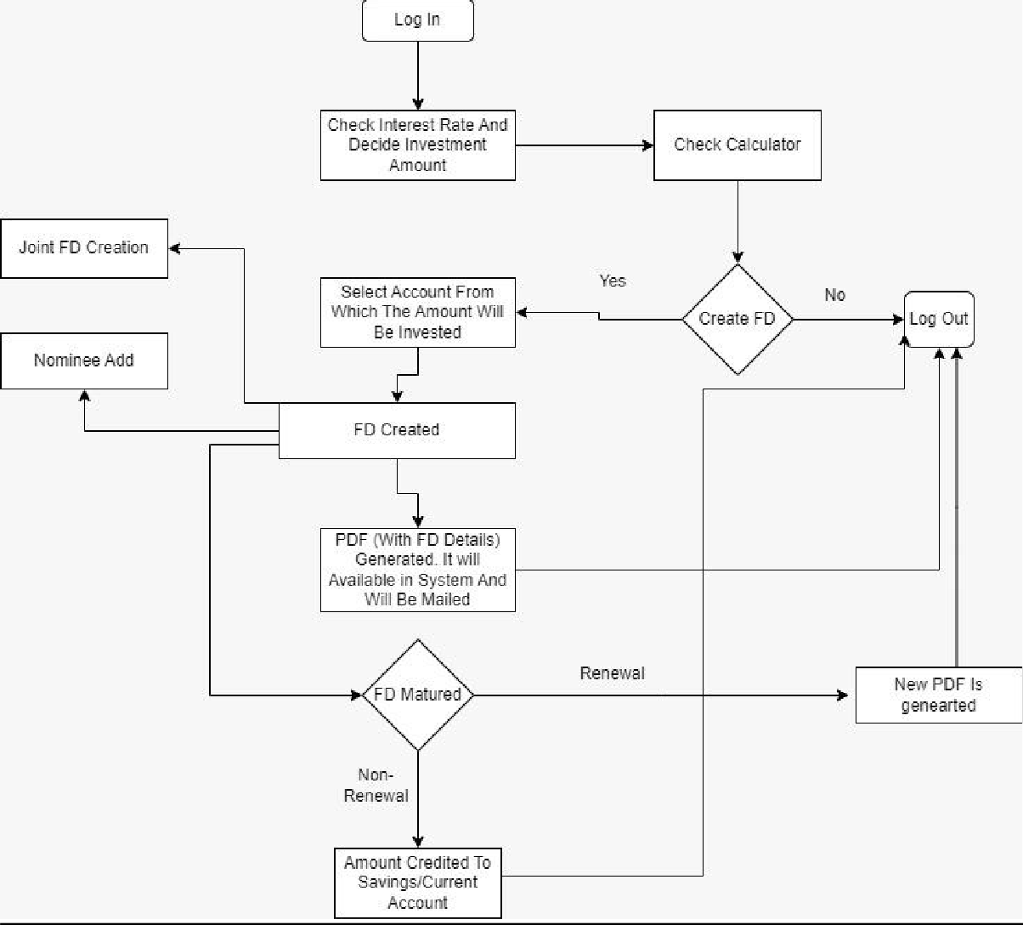

# Scope:

ABC bank is one leading bank across the globe. They want to go 100% online and they want to start the initiative by introducing E-Fixed Deposit. The bank wants to introduce the E-FD to their existing customers (who have account in the ABC Bank.) By introducing E-Fixed Deposit –

1. The time taken for creation of FD will be less. The customers will not be required to bank to create the FD and process will be seamless and hassle free.
2. The payment process will be extremely easy and can be done directly through net banking.
3. The renewal and closure process will be easier. As these processes will not be required to visit bank anymore.

# Features Need To Be Developed:

1. Provision to create Fixed Deposit through the web portal and mobile app of ABC Bank.
2. Provision to select appropriate FD option based on tenure and interest rate for normal users and senior citizens.
3. Develop a calculator to get the matured amount by inserting amount, tenure and user age.
4. Provision to deduct investment amount from account. This case is

applicable for the customers who have multiple account in the ABC Bank.

1. Provision to renew/ close fixed deposit from the E-FD system.
2. Provision to create joint fixed deposits by tagging the other customer’s name and SSN ID.
3. Provision to add nominee along with the nominee’s age. In case of minor nominee, his/her guardian’s details will be added.
4. Provision of generation of PDF copy (carrying the details of the fixed deposit).
5. Provision to email automatically of the PDF copy to the registered email id.
6. Provision to reflect the PDF copy in the online bank account and mobile banking app.
7. Provision to generate reports by the employees of the ABC Bank.

# In-Scope:

1. Creation of fixed deposit of the existing customers who have account with the ABC Bank via web-portal/mobile banking app.
2. Selection of one account (in case the customer has multiple bank accounts with ABC Bank) from which the amount of investment will be deducted.
3. Calculator to get the matured amount of a fixed deposit by inserting whether the customer’s age (regular/senior citizen), amount to be

invested, tenure of investment.

1. Renewal/closing of Fixed Deposit.
2. Adding nominee.
3. Creating joint fixed deposit by tagging the other customer’s name and SSN ID.
4. PDF generation with Fixed Deposit details.
5. Emailing (automatically) the PDF copy and also be available in the web- portal/mobile banking app.
6. Report generation.

# Out of Scope:

1. Creation of Fixed Deposit by the users who do not have account with ABC Bank.
2. Transferring the Fixed Deposit.

# Wireframe:

1. **Overview Page of Online Banking:**

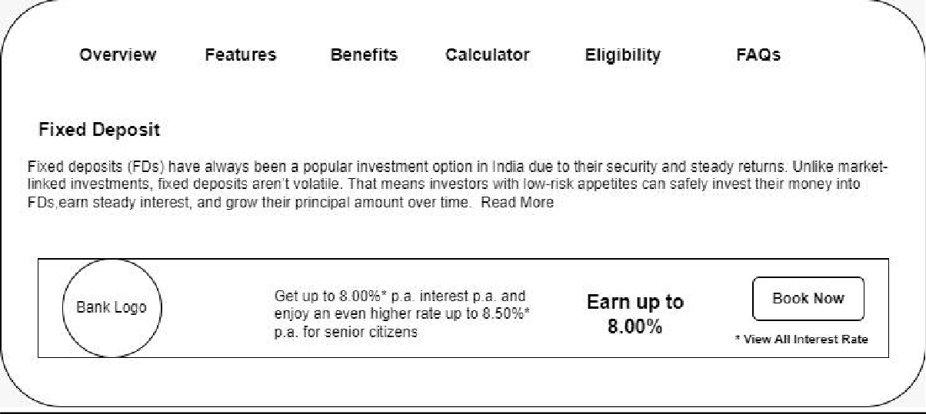

# Calculator:

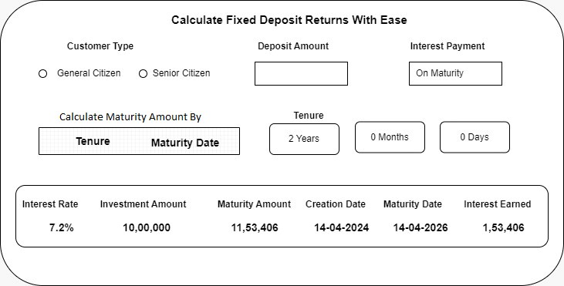

**Functional Requirement:**

1. **Customers:**
2. Customer will be able to create a fixed deposit by logging in the web- portal/ mobile banking app.
3. The system can check if the customer has web-portal/ mobile banking app and account with the ABC Bank.
4. Details of the tenure and interest rate against the investment amount for normal customers and senior-citizens to be available within the system.
5. Calculator to get the matured amount against an investment based on tenure and age of the customer.
6. Options to choose from which account the amount will be deducted for the Fixed Deposit.
7. Options to close the fixed deposit and selection of account, where the matured amount will be credited.
8. Renew the fixed deposit.
9. Option to add nominee.
10. Option to create joint fixed deposit based on the partner’s name, SSN ID.
11. **Bank Employee/ Management:**
12. Generation of different reports by the bank employees/ management to get the amount invested based on tenure, interest paid etc.
13. Employees/ management will be able to export the reports in PDF and in excel.

# Non-Functional Requirement:

* 1. PDF will be generated with the details of the Fixed Deposit and will be automatically mailed to customer’s registered email id.
  2. PDF will also be available in the system and can be seen once log in the web-portal/ banking app.

# Tableau Task:

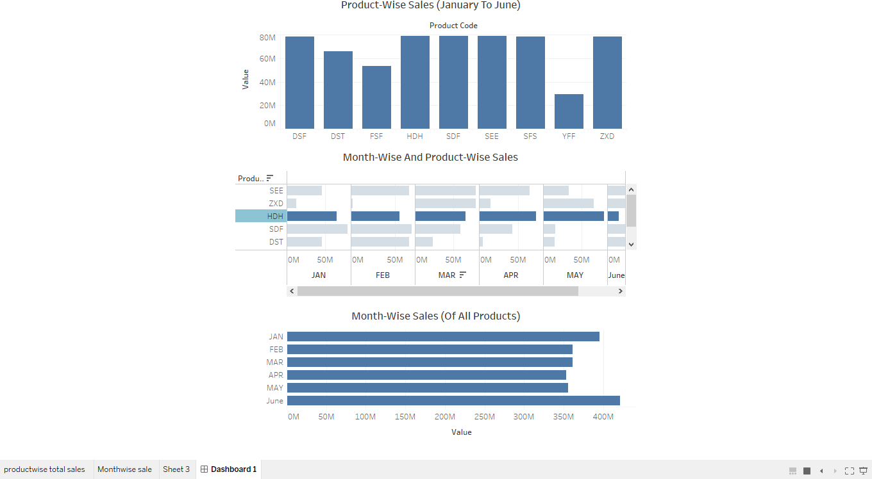

**Excel:**

# Question 1:

**FD Sales For Different Periods Of Investment (Normal**

**Users)**

90 M

80 M

70 M

60 M

50 M

40 M

30 M

20 M

10 M

M

7 - 14 days 91 days – 6 46 – 90 days 1 year 1 day 15 - 45 days 3 years 1 day2 years 1 day 5 years 1 day

months – 2 years – 5 years – 3 years – 10 years

**FD Sales For Different Periods Of Investment (Senior**

**Citizens)**

1200 M

1000 M

800 M

600 M

400 M

200 M

M

Period

7 - 14 91 days – 46 – 90 1 year 1

days 6 months days

day – 2

years

15 - 45

days

3 years 1 2 years 1 5 years 1

day – 5

years

day – 3 day – 10

years

years

**Ascending Order:**

|  |  |  |  |
| --- | --- | --- | --- |
| Period | Rates for amounts <2 crores |  |  |
|  | User FDs created worth: | Senior Citizen FDs created | Total |

|  |  |  |  |
| --- | --- | --- | --- |
|  |  | worth: |  |
| 5 years 1  day – 10  years | 94,51,664 | 1,94,51,664 | 2,89,03,328 |
| 2 years 1  day – 3 years | 1,54,84,844 | 11,54,84,844 | 13,09,69,688 |
| 3 years 1  day – 5 years | 4,55,97,911 | 14,55,97,911 | 19,11,95,822 |
| 15 - 45 days | 7,87,87,777 | 24,54,54,541 | 32,42,42,318 |
| 1 year 1 day  – 2 years | 1,21,21,451 | 31,54,84,844 | 32,76,06,295 |
| 46 – 90 days | 4,54,54,541 | 34,54,44,578 | 39,08,99,119 |
| 91 days – 6 months | 4,54,44,578 | 47,84,51,511 | 52,38,96,089 |
| 6 months 1 day to 1 year | 7,84,51,511 | 51,21,21,451 | 59,05,72,962 |
| 7 - 14 days | 6,47,26,472 | 99,89,89,888 | 1,06,37,16,360 |

# Descending Order:

|  |  |  |  |
| --- | --- | --- | --- |
| Period | Rates for amounts <2 crores |  |  |
|  | User FDs created worth: | Senior Citizen FDs created  worth: | Total |
| 7 - 14 days | 6,47,26,472 | 99,89,89,888 | 1,06,37,16,360 |
| 6 months 1  day to 1 year | 7,84,51,511 | 51,21,21,451 | 59,05,72,962 |
| 91 days – 6  months | 4,54,44,578 | 47,84,51,511 | 52,38,96,089 |
| 46 – 90 days | 4,54,54,541 | 34,54,44,578 | 39,08,99,119 |
| 1 year 1 day  – 2 years | 1,21,21,451 | 31,54,84,844 | 32,76,06,295 |
| 15 - 45 days | 7,87,87,777 | 24,54,54,541 | 32,42,42,318 |
| 3 years 1  day – 5 years | 4,55,97,911 | 14,55,97,911 | 19,11,95,822 |
| 2 years 1  day – 3 years | 1,54,84,844 | 11,54,84,844 | 13,09,69,688 |
| 5 years 1  day – 10  years | 94,51,664 | 1,94,51,664 | 2,89,03,328 |

**Question 2:**

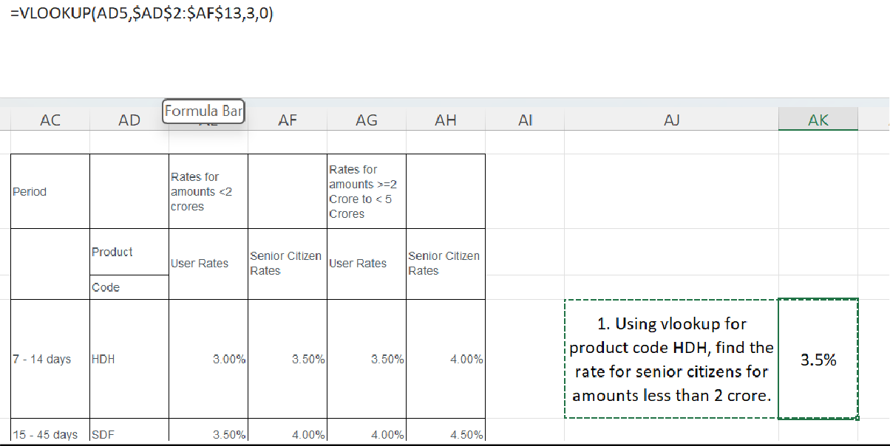

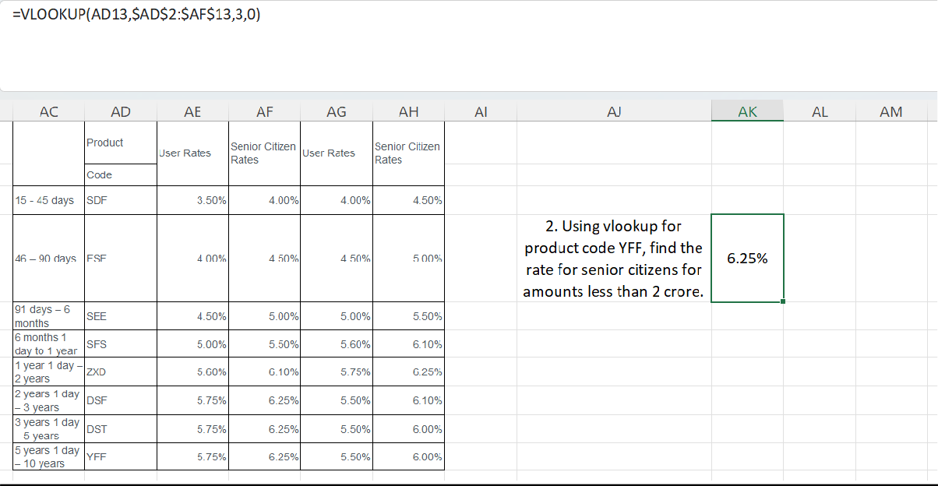

# Product Backlog:

**Internet Banking:**

|  |  |  |  |  |  |
| --- | --- | --- | --- | --- | --- |
| **Epic/**  **Story ID** | **Title** | **Theme** | **Story**  **Point** | **Acceptance**  **Criteria** | **Iteration**  **Path** |
| Fixed Deposit- 1/ FD-4  Fixed Deposit- 1/ FD-5 | As a customer of ABC Bank, the customer can create a fixed deposit  via online  Banking account, mobile banking.  The customer can check out different interest applicable on different tenure, investment amount and for normal/senior citizen so that the customer can chose from the options | Internet Banking  Internet Banking | 7  1 | Given that the customer has the access to online banking, if the customer is a valid and has account with ABC Bank  then the customer can create a FD with ABC Bank.  The customer can view the various FD plans offered by the bank with the following details –   * Period (7 days to 10 years with appropriate interval) * Profile (Normal/se nior citizen) * Amount invested   (Rates for amount  <1.5 million USD or  >=1.5  million USD  to <4 | Release 1/ Sprint 1  Release 1/ Sprint 1 |

|  |  |  |  |  |  |
| --- | --- | --- | --- | --- | --- |
| Fixed Deposit- 1/ FD-6  Fixed Deposit - 1/ FD – 7 | The customer can use the calculator available in to get the maturity amount, interest  earned based on the investment amount, interest rate, tenure and customer profile  (normal/senior citizen).  The customer can  decide which ABC Bank account the customer wants the amount to deduct from | Internet Banking  Internet Banking | 3  3 | million USD)  The customer can calculate the  maturity amount and interest  earned based on the interest rate given in the  website by providing the below details –   * Investment amount * Tenure * Profile * Interest payment   interval (on maturity/ monthly/ quarterly/ half-yearly/ yearly)  The customer who holds multiple bank  accounts in the ABC Bank should  be able to choose from which account the amount will be deducted. | Release 1/ Sprint 1  Release 1/ Sprint 1 |

|  |  |  |  |  |  |
| --- | --- | --- | --- | --- | --- |
| Fixed Deposit - 1/ FD – 8  Fixed Deposit – 1/ FD - 9  Fixed Deposit - 1/ FD - 10 | The customer can  decide if the customer wants to renew the  fixed deposit before the FD gets matured  The customer can  decide which ABC Bank account the customer wants the mature amount be credited in.  The customer can have the option of creating a joint FD with other customer of the ABC Bank | Internet Banking  Internet Banking  Internet Banking | 3  3  2 | Before the FD gets matured the customer will be provided the option of renewal of the FD with a fixed tenure  decided by the Administrator.  In case the customer has multiple accounts (be it  savings/current), the customer can decide in which account the customer wants  the matured amount to be credited.  During the  creation of the FD the customer will have the option to create a joint FD with other customer of the  ABC Bank. SSN  details will be  required to create the joint FD. | Release 1/ Sprint 1  Release 1/ Sprint 1  Release 1/ Sprint 1 |

|  |  |  |  |  |  |
| --- | --- | --- | --- | --- | --- |
| Fixed Deposit - 1/ FD – 11  Fixed Deposit - 1/ FD – 12 | The customer can add nominee in the FD so that nominee is  benefitted in case of unfortunate event  The customer will have a PDF copy (with all the details of Fixed Deposit) in the system and also  this PDF copy will be emailed in the  registered email id of the customer. | Internet Banking  Internet Banking | 2  2 | The customer can add nominee in  the fixed deposit with the following details of the nominee –   * Name * Age * Relation   In case of a minor nominee,  guardian details are mandatory.  A PDF copy will be generated once  the Fixed Deposit is created with all the details of the Fixed Deposit. The PDF copy will be automatically be emailed to customer’s email  id and all will be available in the system for future reference. | Release 1/ Sprint 1  Release 1/ Sprint 1 |

# Mobile Banking:

|  |  |  |  |  |  |
| --- | --- | --- | --- | --- | --- |
| **Epic/**  **Story ID** | **Title** | **Theme** | **Story**  **Point** | **Acceptance Criteria** | **Iteration**  **Path** |
| Fixed Deposit- 2/ FD-  13  Fixed Deposit- 2/ FD-  14 | As a customer of ABC Bank, the customer can create a fixed deposit via mobile application.  The customer can check out different  interest  applicable on different  tenure,  investment amount and for normal/senior citizen so that the customer can chose from the options | Mobile  Application  Mobile  Application | 7  1 | Given that the customer has the access to mobile application, if the customer is a valid and has account  with ABC Bank then the customer can create a FD with  ABC Bank.  The customer can  view the various FD plans offered by the bank with the  following details –   * Period (7 days to 10 years   with appropriate interval)   * Profile (Normal/seni or citizen) * Amount invested   (Rates for amount <1.5 | Release 1/ Sprint 2  Release 1/ Sprint 2 |

|  |  |  |  |  |  |
| --- | --- | --- | --- | --- | --- |
| Fixed Deposit- 2/ FD-  15  Fixed Deposit  -2/ FD – 16 | The customer can use the calculator available in to get the  maturity amount, interest  earned based on the  investment amount,  interest rate, tenure and customer profile (normal/senior citizen).  The customer can decide  which ABC Bank account the customer wants the amount to deduct from | Mobile  Application  Mobile  Application | 3  3 | million USD or  >=1.5 million  USD to <4  million USD)  The customer can calculate the  maturity amount and interest earned based on the  interest rate given in the website by  providing the below details –   * Investment amount * Tenure * Profile * Interest payment   interval (on maturity/ monthly/ quarterly/ half-yearly/ yearly)  The customer who holds multiple bank accounts in the ABC Bank should be able to choose from  which account the amount will be  deducted. | Release 1/ Sprint 2  Release 1/ Sprint 2 |

|  |  |  |  |  |  |
| --- | --- | --- | --- | --- | --- |
| Fixed Deposit  -2/ FD – 17  Fixed Deposit  – 2/ FD  - 18  Fixed Deposit  -2/ FD -  19 | The customer can decide if the customer wants to  renew the fixed deposit before the FD gets matured  The customer can decide  which ABC Bank account the customer wants the mature amount be credited in.  The customer can have the option of  creating a joint | Mobile  Application  Mobile  Application  Mobile  Application | 2  2  2 | Before the FD gets matured the customer will be provided the option of renewal of the FD with a fixed tenure decided by the  Administrator.  In case the customer has multiple accounts (be it  savings/current), the customer can decide in which account  the customer wants the matured amount to be  credited.  During the creation of the FD the customer will have  the option to create | Release 1/ Sprint 2  Release 1/ Sprint 2  Release 1/ Sprint 2 |

|  |  |  |  |  |  |
| --- | --- | --- | --- | --- | --- |
| Fixed Deposit  -2/ FD – 20  Fixed Deposit  -2/ FD – 21 | FD with other customer of  the ABC Bank  The customer can add nominee in  the FD so that nominee is benefitted in case of  unfortunate event  The customer will have a PDF copy (with all  the details of Fixed Deposit) in the system and also this PDF copy will be emailed in the registered email id of the customer. | Mobile  Application  Mobile  Application | 2  2 | a joint FD with other customer of the ABC Bank. SSN details  will be required to create the joint FD.  The customer can add nominee in the fixed deposit with  the following details of the nominee –   * Name * Age * Relation   In case of a minor nominee, guardian details are mandatory.  A PDF copy will be generated once the Fixed Deposit is  created with all the details of the Fixed Deposit. The PDF copy will be automatically be  emailed to customer’s email id and all will be  available in the | Release 1/ Sprint 2  Release 1/ Sprint 2 |

|  |  |  |  |  |  |
| --- | --- | --- | --- | --- | --- |
|  |  |  |  | system for future reference. |  |

**Reports:**

|  |  |  |  |  |  |
| --- | --- | --- | --- | --- | --- |
| **Epic/**  **Story ID** | **Title** | **Theme** | **Story**  **Point** | **Acceptance**  **Criteria** | **Iteration**  **Path** |
| Fixed Deposit  -3/ FD – 22 | An employee can  generate below reports to make better  decisions –   * Total value of FDs for user for tenure less than 6 months for normal customers * Total value of FDs for user for tenure less than 6 months * Total values of FDs for user for tenure 6 months 1 day and 1 year for normal user. * Total values of FDs for user for tenure 6 months 1 day and 1 year for senior   citizens.   * Number of FDs that are more   than 1.5 million USD for normal users. | Backend | 5 per Report | As an  employee of the ABC Bank, one can  generate and view the  reports. | Release 1/ Sprint 3 |

|  |  |  |  |  |  |
| --- | --- | --- | --- | --- | --- |
| Fixed Deposit  -3/ FD – 23 | * Number of FDs that are more   than 1.5 million USD for senior citizens  .  An employee can download the reports in excel format to analyse the data | Backend | 1 per report | An  employee of the ABC Bank can download the report with a click  of a button | Release 1/ Sprint 3 |